**Team: C**



***Genuine Technology & Research Ltd***

**Monthly Report of Internship (22/07/2019-21/08/2019)**

**Supervised By**

**Ifran Ali Sakib**

Software Development

Genuine Technology & Research Ltd

**Submitted By**

**Md. Rafiqul Islam Sadik**

&

**Md. Nahin Hossain Shanto**

Date of Submission:24th August, 2019

***Introduction:***

My Name Is Rafiqul Islam Sadik and my team mate is Nahin Hossain Shanto. We joined 22th July in Genuine Technology Research Ltd. Now we will deliver a progress report in our internship period.

First Day in our office our project manager called a meeting. In that meeting all intern member participated. Then our project manager explains us working procedure and made groups at internship period. He assigned us two tasks. Our tasks are to develop Chat application and Third-Party Application.

When we understand our task made a plan how we done our project within dead line. To develop this application every time we follow software development life cycle. Office authority told us to attend 3 days in the office. But our project work has to be done in our home. Now we will describe what we done first month on internship period.

**First Week (22.07.2019-25.07.2019) :**

First week we are planning how we will develop this apps. Then we search google and research many things. In this week we found an easy way to develop a real time chat application but we could no found any idea about third party application. In this week we collect different idea from google and you tube to develop the project.

**Second Week (27.07.2019-01.08.2019) :**

In this week we collect requirement for our projects. Then we prepare use case diagram, activity diagram, sequence diagram, dataflow diagram, class diagram, ER diagram. When we prepared class diagram and ER diagram, we face many problems. In this time, we solved these problems by group discussion. In this week we prepare a documentation and send this documentation to our supervisor.

In this week we learn how to work in Microsoft project management tool. This is very helpful for us to manage our project.

**Third Week (3.08.2019-08.08.2019) :**

This week is very important for us because in this week, the honorable managing director of GTR discuss with us about our tasks. In this meeting we learned many things from him. He told us at first to develop chat application. Then he gives us many important suggestions to develop this application.

In this week we saw different demo project form you tube, github and many websites. Seeing that demo project we gathered our knowledge and planning how to develop real time chat application.

**Forth Week (10.08.2019-16.08.2019) :**

In this week we found an Eid Vacation. In this vacation we also work with my team mate using Team viewer and Zoom. In this week we create a project in visual studio. Then we will try to design UI and database for chat application. In this vacation we use time properly to prepare our project. In this vacation we done 30% work to implement chat application.

**Fifth Week (17.08.2019-22.08.2019) :**

In this week we faced many problems to develop the project. We solved our problem by group discussion and found many suggestions from google to solved those problem. In our chat application user found login, registration, globally chat, invaluably chat feature. User can see who are online and when he or she login. In our chat application user can send photo, doc file, pdf file etc. User Can change profile picture.

In our chat application we hope 70-80% work done. Our chat application is a real time chat application. We use SignalR library to develop these projects. Now we face only one problem in this application. When a user chats another user and sent messages the message was not store in database for this reason when a user logout, these messages was vanished. Now we will try to store that messages.

**Project Demo:**

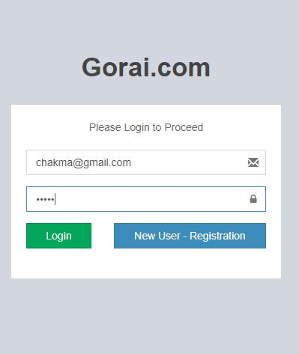

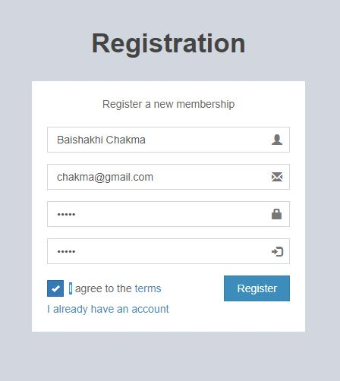

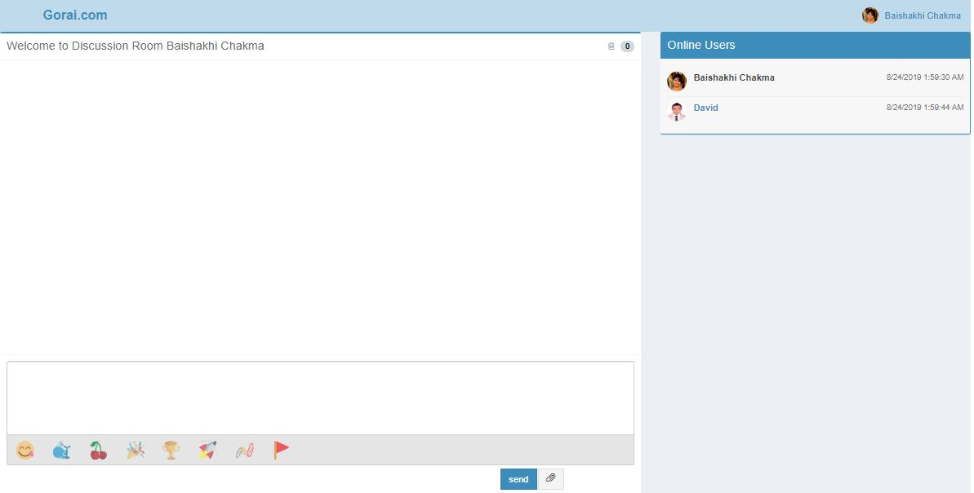

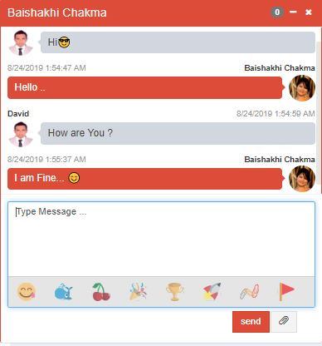

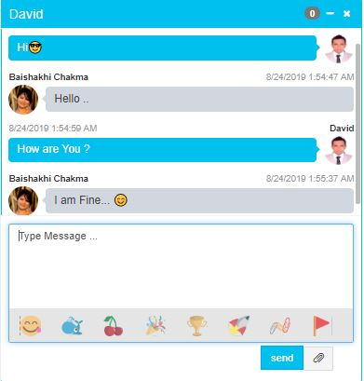

***Conclusion:***

We can honestly say that our time spent interning with Genuine Technology Research Limited resulted in one of the best moments of our life.  Not only did we gain practical skills but we also had the opportunity to meet many fantastic people. The atmosphere at the office was always welcoming which made us feel right at home. Additionally, we felt like we were able to contribute to the company by assisting and working on projects throughout the internship period.